|  |  |
| --- | --- |
|  | **AIR UNIVERSITY** |
| **DEPARTMENT OF COMPUTER SCIENCE** |
| **LAB TASK 2** |

**Student Name: Hamza Umer Farooq Reg. No: 200789**

**Subject: Compiler Construction Semester: VIII**

**Objective: Frequency of word, even or odd, length of largest word in string**

**ASSESSMENT:**

|  |  |  |  |  |  |
| --- | --- | --- | --- | --- | --- |
| **Attributes** | **Excellent**  **(5)** | **Good**  **(4)** | **Average**  **(3)** | **Satisfactory**  **(2)** | **Unsatisfactory (1)** |
| **Ability to Conduct**  Task |  |  |  |  |  |
| **Ability to assimilate the results** |  |  |  |  |  |
| **Effective use of theorems/postulates/formulas** |  |  |  |  |  |

Total Marks:

Obtained Marks:

**REPORT ASSESSMENT:**

|  |  |  |  |  |  |
| --- | --- | --- | --- | --- | --- |
| **Attributes** | **Excellent**  **(5)** | **Good**  **(4)** | **Average**  **(3)** | **Satisfactory**  **(2)** | **Unsatisfactory**  **(1)** |
| **Data presentation** |  |  |  |  |  |
| **Experimental results** |  |  |  |  |  |
| **Conclusion** |  |  |  |  |  |

**QUESTION 1**

%{

#include <stdio.h>

#include <stdlib.h>

#include <string.h>

int count = 0;

char word[1000] = "";

%}

%%

[a-zA-Z]+ {if(strcmp(yytext, word) == 0) count++;}

. {}

%%

int yywrap(){}

int main() {

    FILE* fp;

    char filename[30];

    printf("Enter word to find: ");

    scanf("%s", word);

    printf("\nEnter File name: ");

    scanf("%s",filename);

    fp = fopen(filename,"r");

    yyin = fp;

    yylex();

    printf("Total Frequency of given word: %d\n", count);

    return 0;

}



**QUESTION 2**

%{

#include <stdlib.h>

#include <stdio.h>

int num1 = 0;

%}

%%

[0-9]+ {

    int num = atoi(yytext);

    if (num % 2 == 0) {

        printf("The Number %d is Even\n", num);

    } else {

        printf("The Number %d is Odd\n", num);

    }

}

. {printf("\n NOT A NUMBER\n");}

%%

int yywrap(){

return 1;

}

int main() {

    printf("Input a Number: ");

    num1 = yylex();

    return 0;

}

**OUTPUT**

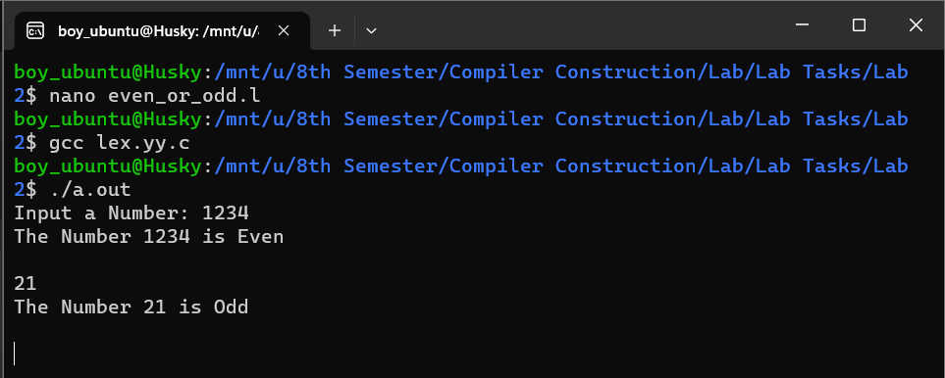

**QUESTION 3**

%{

#include <stdio.h>

int largest = 0;

char largestword[1000] = "";

%}

%%

[A-Za-z0-9]+ {

    int length = yyleng;

    if (length > largest){

            largest = length;

            strcpy(largestword,yytext);}}

\n {

    printf("\nLargest Word is: %s\nLength of largest word is: %d\n",largestword,largest);

}

.  {}

%%

int yywrap(){}

int main(){

    printf("\nEnter a string: ");

    yylex();

    return 0;

}

**OUTPUT**

